**Customer Media Manager**

Apr/9/2017

Laurian Staicu 1696177

Alireza Tabatabaei

Project description

Customer Media manager is an application that combines, organizes and selects media content for a company. Media content is a high value asset for a marketing company. The purchase and use of this content has to be done in a very efficient way. These resources are accumulated in very big number by companies and they have to be organized in such way that the company and the customer make get the best return on investment, especially that very good content is more and more sophisticated and expensive.

In this project we propose a windows bases application that enables the marketing company to select images for a customer project. A package can be added to each selected item when the image is selected. A package represents extra work to modify and adjust the file.

For example if the customer requires that a special filter is applied to the picture then the user selects package 1.

Same picture can be selected with a different package and added to the list.

Also any selected item from the customer list can be removed from the list.

The selected items are added to a list that is saved in the customer’s portfolio profile.

The application will also have a login user and registration process for new employee and customers.

The form will require the name, company and coordinates of a new customer. The information will be saved in a database. A picture list can be added to the customers profile on a specific project. Therefore the customer will have a list of projects. A search by customers of projects can be performed.

A very important feature of the application is image processing like applying a filter (black and with) or cropping the image. These image processing are part of the package value that are assigned to an image. Each package is associated to a cost that is update in the customer profile.

Invoicing is done when the project is shipped to the customer.

Also the application will analyze the media resource for their efficient used by who purchased the media, in how many projects it was used and the value of each project it was incorporated in. Basically any analysis for performance can be implemented.

WE will try to use the following feature technologies:

Bitmap Class

Encapsulates a GDI+ bitmap, which consists of the pixel data for a graphics image and its attributes. A Bitmap is an object used to work with images defined by pixel data.

<https://msdn.microsoft.com/en-us/library/system.drawing.bitmap(v=vs.110).aspx>

Bitmap Effects

Bitmap effects enable designers and developers to apply visual effects to rendered Windows Presentation Foundation (WPF) content. <https://msdn.microsoft.com/en-us/library/ms743435(v=vs.110).aspx>

System.Windows.Media.Imaging Namespace

Provides types that are used to encode and decode bitmap images.

<https://msdn.microsoft.com/en-us/library/system.windows.media.imaging(v=vs.110).aspx>

System.Windows.Media.Animation Namespace

Provides types that support property animation functionality, including timelines, storyboards, and key frames.

<https://msdn.microsoft.com/en-us/library/system.windows.media.animation(v=vs.110).aspx>

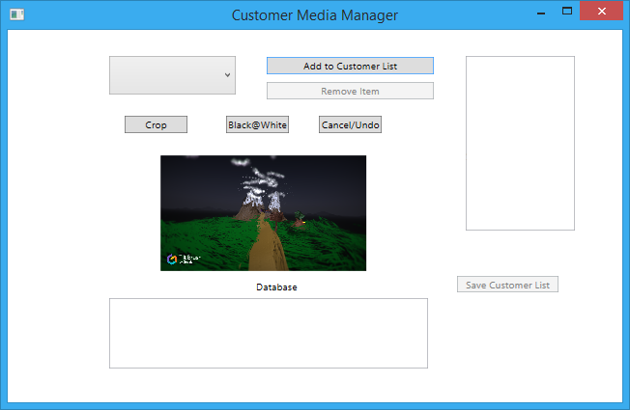

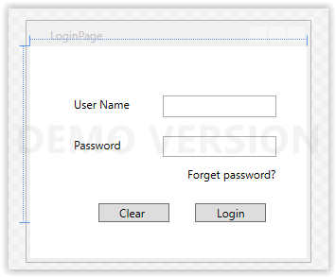

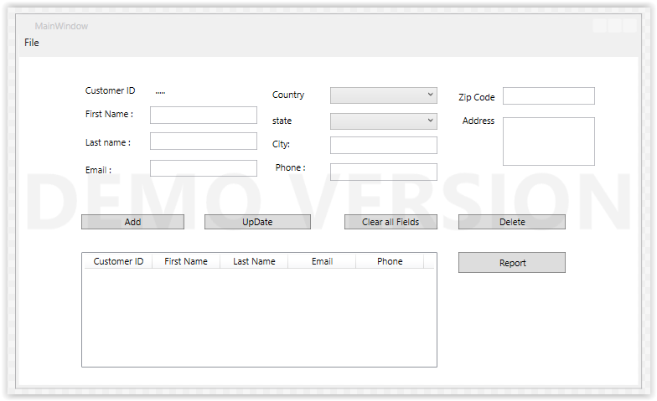

SQL schema:

Our Database will contain 5 tables:

